AES Algorithm

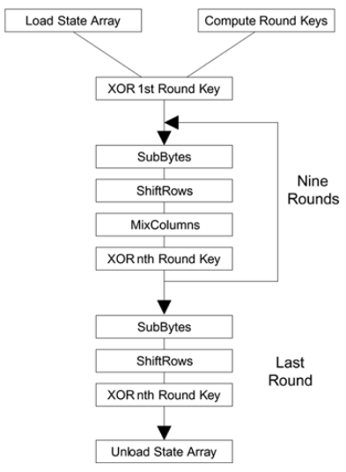

You take the following AES steps of encryption for a 128-bit block:

1. Derive the set of round keys from the cipher key.
2. Initialize the state array with the block data (plaintext).
3. Add the initial round key to the starting state array.
4. Perform nine rounds of state manipulation.
5. Perform the tenth and final round of state manipulation.
6. Copy the final state array out as the encrypted data (ciphertext)